FOR IMMEDIATE RELEASE Media Contact: Clinton Desiderio
March 4th, 2026 (505) 387-7424
clintdesiderio@navajotech.edu

Navajo Technical University Recognized
by Achieving the Dream as a 2026 Leader College

Crownpoint, New Mexico — Navajo Technical University announced today that it has been designated a 2026 Leader College by Achieving the Dream (ATD), a national organization committed to advancing community colleges as accessible hubs of learning, credentialing, and economic mobility.

“I am truly honored to receive this recognition for student success. This award reflects Navajo Technical University’s continued commitment to improving student outcomes and strengthening our institution,” said Dr. Elmer J. Guy, President of Navajo Technical University. “It represents the collective effort of our dedicated faculty, staff, supportive families, and, most importantly, our students. Their resilience, curiosity, and determination inspire everything we do. Through our partnership with Achieving the Dream, we continue to use data-informed strategies to expand opportunities, strengthen pathways to completion, and prepare our students for workforce success and community advancement across the Navajo Nation. I also want to thank ATD and Coach Dr. Connie Green for believing in our mission and supporting our work to improve student achievement.”

Leader Colleges are recognized for meaningful progress in expanding access; improving early momentum metrics, such as retention; advancing relevant student success strategies with evidence of implementation and early results; and growing institutional capacity through culture and capacity-building efforts.

Navajo Technical University has been part of the ATD Network since 2017.

“The 2026 Leader Colleges demonstrate sustained commitment and measurable progress in advancing student success,” said Dr. Karen A. Stout, president and CEO of Achieving the Dream. “By using data to guide decisions and continuously strengthen their practices, these institutions are producing real gains in student outcomes, strengthening their practices, and deepening their impact in the communities they serve. Their leadership sets a powerful example for colleges across the ATD Network, reflecting the focus, discipline, and follow-through required to achieve lasting institutional change.”

###

About Achieving the Dream

Achieving the Dream (ATD) is a partner and champion of more than 300 community colleges across the country. Drawing on expert coaches, groundbreaking programs, and national peer network, the organization provides institutions with integrated, tailored support for every aspect of their work — from foundational capacities such as leadership, data, and equity to intentional strategies for supporting students holistically, building K–12 partnerships, and more. ATD calls this Whole College Transformation. Its vision is for every college to be a catalyst for equitable and economically vibrant communities. ATD knows that with the right partner and the right approach, colleges can drive access, completion rates, and employment outcomes — so that all students can access life-changing learning that propels them into community-changing careers. Follow ATD on X (Twitter), Facebook, and LinkedIn. To learn more, visit the Achieving the Dream (ATD) website: www.achievingthedream.org.

About Navajo Technical University

Navajo Technical University (NTU) is a public tribal university located in Crownpoint, New Mexico, with additional instructional sites across the Navajo Nation. Chartered by the Navajo Nation, NTU provides quality higher education grounded in Diné culture, language, and values while preparing students for careers in science, technology, engineering, mathematics, the skilled trades, and other professional fields. Through hands-on learning, community partnerships, and workforce-focused programs, NTU is committed to empowering students, strengthening tribal communities, and supporting economic development across the region.

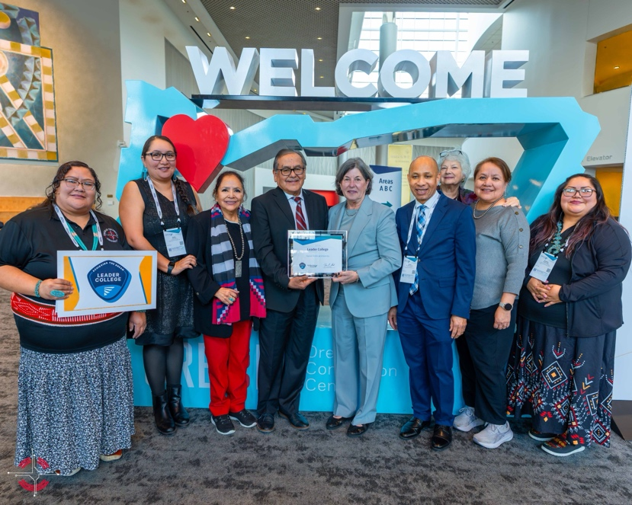

(L-R) Sheena Begay, NTU Director of Institutional Data & Reporting, Adela Bob, NTU Financial Aid Manager, Dr. Coleen Bowman, NTU Provost, Dr. Elmer Guy, NTU President, Dr. Karen A. Stout, President and CEO of Achieving the Dream, Dr. Connie Green, ATD Coach, Jerlynn Henry, NTU Dean of Student Services, and Shawna Begay, NTU Career Services Coordinator, holding 2026 Leader College certificate that was presented from the Achieving the Dream organization.

