FOR IMMEDIATE RELEASE Media Contact: Clinton Desiderio
February 13, 2026 (505) 387-7424
clintdesiderio@navajotech.edu

Diné Higher Education Act Signed into Law

WINDOW ROCK, Ariz. — On Friday, February 13, 2026, at the Navajo Nation President’s Office in Window Rock, leaders from Navajo Technical University (NTU) joined representatives from Diné College and the Office of Navajo Nation Scholarship and Financial Assistance (ONNSFA) for the official signing of Legislation No. 0169-25, the Diné Higher Education Grant Fund Act.

The legislation was signed into law by Buu Nygren, President of the Navajo Nation. In attendance were NTU President Elmer Guy, former NTU Board President Tom Platero, and NTU Board President Tara Denetsosie-Lovato, along with leaders from Diné College and ONNSFA.

Legislation 0169-25 was approved by the Navajo Nation Council during the 25th Navajo Nation Council Winter Session. The bill was sponsored by Honorable Delegate Andy Nez and co-sponsored by Honorable Delegate Carl R. Slater. The measure passed unanimously, authorizing $19 million in funding, including $6 million each for Navajo Technical University and Diné College and $$7 million for ONNSFA.

The new authorization represents an increase from the previous allocation and reaffirms the Navajo Nation’s commitment to expanding higher education access, strengthening scholarship opportunities, and supporting institutional growth.

NTU President Dr. Elmer Guy expressed gratitude for the collaborative effort that made the legislation possible.

“I would like to thank Diné College, ONNSFA, and all of our partners who came together to make this legislation a reality,” said Dr. Guy, NTU President. “Our special appreciation goes to Delegate Andy Nez for his leadership and dedication. This investment reflects our shared belief that education is the foundation of a strong and self-sustaining Navajo Nation. When we invest in our students, we invest in the future of our communities.”

NTU Board President Tara Denetsosie-Lovato highlighted the direct impact on students.

“Meeting our students is always inspiring,” Denetsosie-Lovato, NTU Board President said. “Many are recipients of ONNSFA support and are benefiting from the programs offered through our institutions. It is encouraging to see these three entities working together to achieve this goal for our students and to strengthen opportunities for the next generation.”

Although unable to attend the signing ceremony, Delegate Dr. Andy Nez shared his reflections:

“I extend my appreciation to the President of the Navajo Nation for signing Legislation 0169-25 into law. Over 20 years ago, the Navajo Nation Council planted a seed. Over time, that seed has been watered and nourished by many leaders and advocates. I am honored to be part of a team that has reflected on our past efforts and replanted for the future. May our students continue to grow and thrive — they are the cornerstone of our Nation’s progress.”

President Buu Nygren emphasized the importance of investing in tribal institutions.

“The best place we can invest is in our own institutions,” President Nygren said. “I am grateful to Delegate Andy Nez and the Navajo Nation Council for their unanimous support. When it comes to our students, there are no disputes. We must provide the best resources and opportunities possible to ensure their success.”

The signing of Legislation 0169-25 marks a significant milestone in the continued partnership among the Navajo Nation, Navajo Technical University, Diné College, and ONNSFA, reinforcing a unified commitment to advancing Diné higher education and empowering future generations.

###

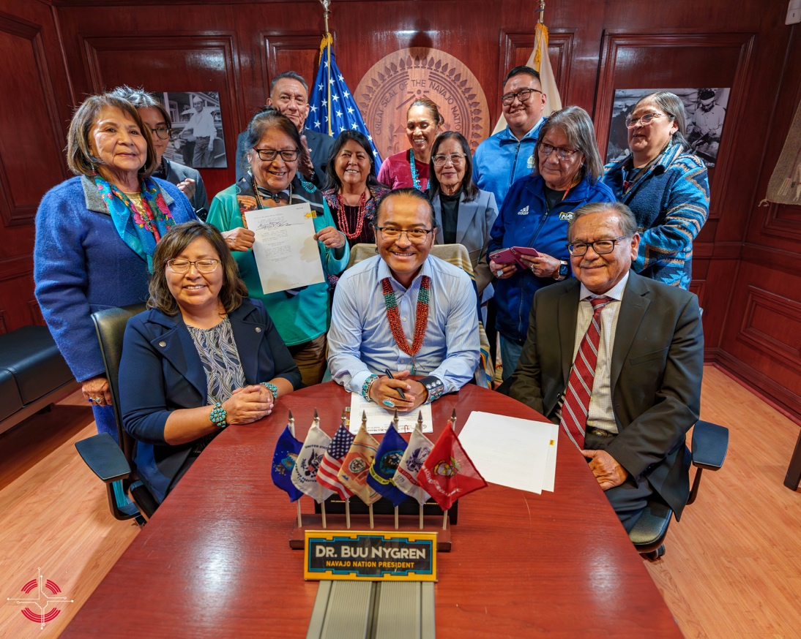

The official signing of Legislation No. 0169-25, the Diné Higher Education Grant Fund Act.
with Navajo Nation President, Navajo Technical University, Diné College and the Office of Navajo Nation Scholarship and Financial Assistance (ONNSFA).

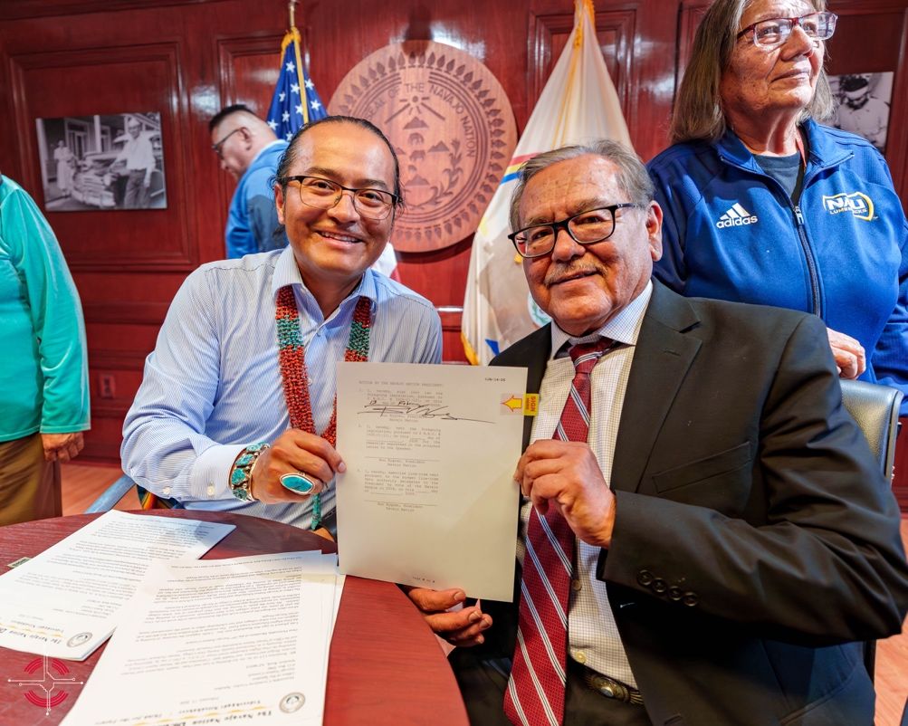

(L-R) Dr. Buu Nygren ,Navajo Nation President, and Dr. Elmer Guy, Navajo Technical University President holding the signed Legislation No. 0169-25, the Diné Higher Education Grant Fund Act.

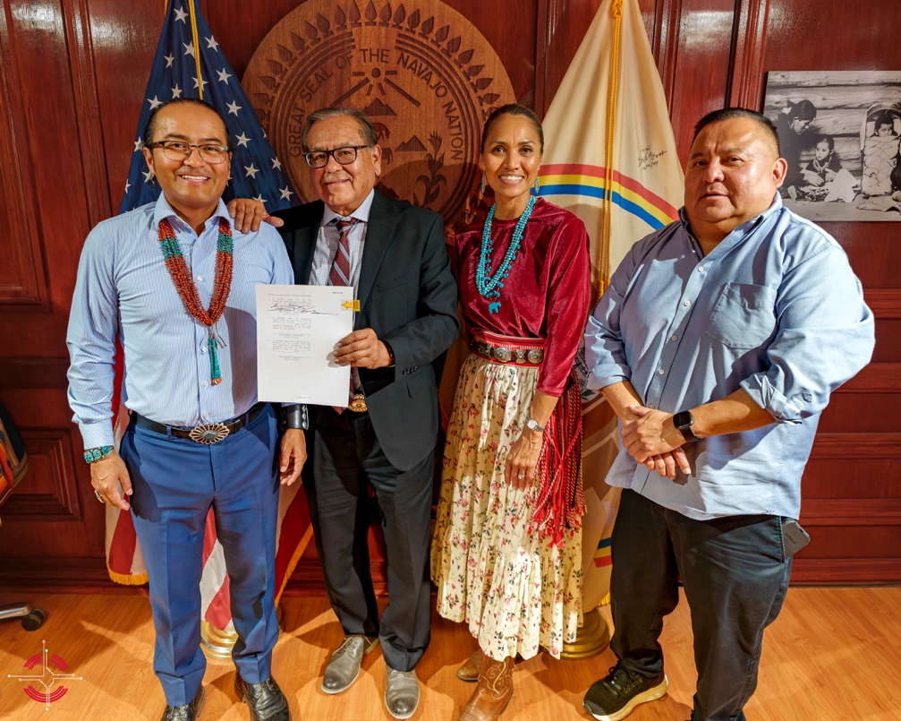
(L-R) Dr. Buu Nygren, Navajo Nation President, Dr. Elmer Guy, Navajo Technical University President, Tara Denetsosie-Lovato, Navajo Technical University Board President, Tom Platero, former NTU Board President, holding the signed Legislation No. 0169-25, the Diné Higher Education Grant Fund Act.

